


AB Bank Zambia

Monthly Report
May 2025

Contents
1. Executive Summary 2
1.1. Key Highlights: 2
1.1.1. Incident Volume & Trends: 2
1.1.2. Detection & Response Performance: 2
1.2. Incident Trends & Analysis: 3
1.3. High-Severity Incidents: 4
2. May Alerts & Incidents Overview 4
2.1. Overall Volume 4
2.2. Incidents Processing 5
2.3. Mean Time To Detect (MTTD) 5
3. Incidents Highlights 5
3.1. Top Incidents by type 5
3.2. Analysis of Key Incident Trends 6
1. MSSQL Account Logon Failure (452 incidents) 6
2. FortiGate Successful Login (328 incidents) 6
3. Admin Account Logon Failure (309 incidents) 6
4. Brute Force Attempts to Windows Servers (204 incidents) 7
5. SQL Service Stopped (175 incidents) 7
6. FortiGate Configuration Change (98 incidents) 7
7. FortiGate Logon Failure (76 incidents) 7
8. ABBANK\rm_rasford.lembalemb Has Made Modifications to Group Policy Objects (75 incidents) 7
9. User Account Modified (66 incidents) 8
10. Authentication Attempt - Default Account (52 incidents) 8
3.3. High Severity 9
3.3.1. High Severity Incidents Analysis 9
1. ABBANK\rm_rasford.lembalemb Has Made Modifications to Group Policy Objects (75 incidents) 9
2. ABBANK\rm_mwenya.kaunda Has Made Modifications to Group Policy Objects (1 incident) 9
4. Conclusion and Recommendations 9
4.1. Recommendations 9
4.2. Conclusion 10

Executive Summary
This security report provides an in-depth analysis of security incidents, alerts, and operational activities managed by Teknowledge for AB Bank Zambia during the reporting period. The findings highlight key security trends, detection and response performance, and proactive measures taken to enhance the organization’s security posture.

Key Highlights:

Incident Volume & Trends:
- A total of 2246 security incidents were processed in Microsoft Sentinel, encompassing both manually investigated cases and automated detections.
- The most prevalent security events still includes MSSQL Account Login Failure, Fortigate Successful Login, Admin Account Login Failure and Brute force Attempts to Windows Server, highlighting the efficacy of identity protection, access control and identify targeted attacks.

Detection & Response Performance:
Mean Time to Detect (MTTD): 5 minutes and 11 seconds, ensuring timely identification of potential threats.
Additionally, the breakdown of MTTD by severity is as follows:
High Severity: 3 minutes and 11 seconds
Medium Severity: 5 minutes and 12 seconds
Informational: 7 minutes and 23 seconds

Mean Time to Resolution (MTTR): The average Mean Time to Resolution (MTTR) for this reporting period was 32 minutes across all severity levels. The screenshot below provides a detailed breakdown by severity, further highlighting the efficiency and responsiveness of our incident handling process.

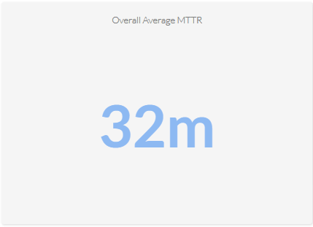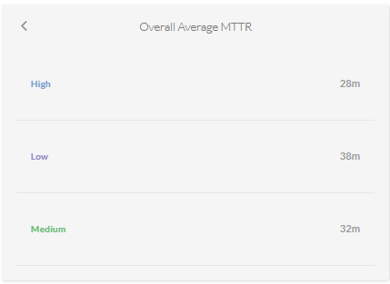

Average time to First Response: The average Time to First Response was 12 minutes. This reflects our enhanced alert triaging and faster engagement timelines. See the screenshot below for the breakdown.
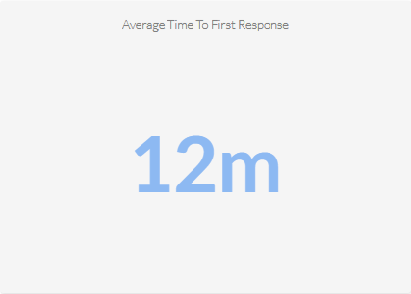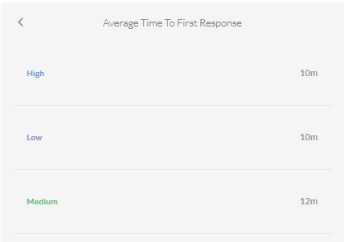

Incident Trends & Analysis:
The top recurring incident types identified in May accounted for 1468 of the total incidents. These incidents were mainly tied to MSSQL Account Logon Failure, Fortigate Successful login, Admin Account Logon Failure, Brute Force Attempts on Windows Server and SQL Service Stopped, indicating High administrative activities and highlighting potential areas where policy enforcement could be strengthened.
The most frequent alerts were related to:
- MSSQL Account Logon Failure – 452
- Fortigate Successful login – 328
- Admin Account Logon Failure – 309
- Brute Force Attempts on Windows Server – 204
- SQL Service Stopped – 175
All these incidents were thoroughly reviewed and remediated where necessary, helping to maintain a stable and secure environment.

High-Severity Incidents:
A total of 76 alerts were categorized as high severity, which entails Group Policy Modification. The high-severity case was fully investigated and confirmed to be authorized and resolved, with no signs of compromise.

May Alerts & Incidents Overview

Overall Volume
In the month of May, a total of 2246 incidents were handled on MS Sentinel. This volume includes both incidents that were manually processed by our security team and those that were automatically addressed through pre-configured automation protocols.
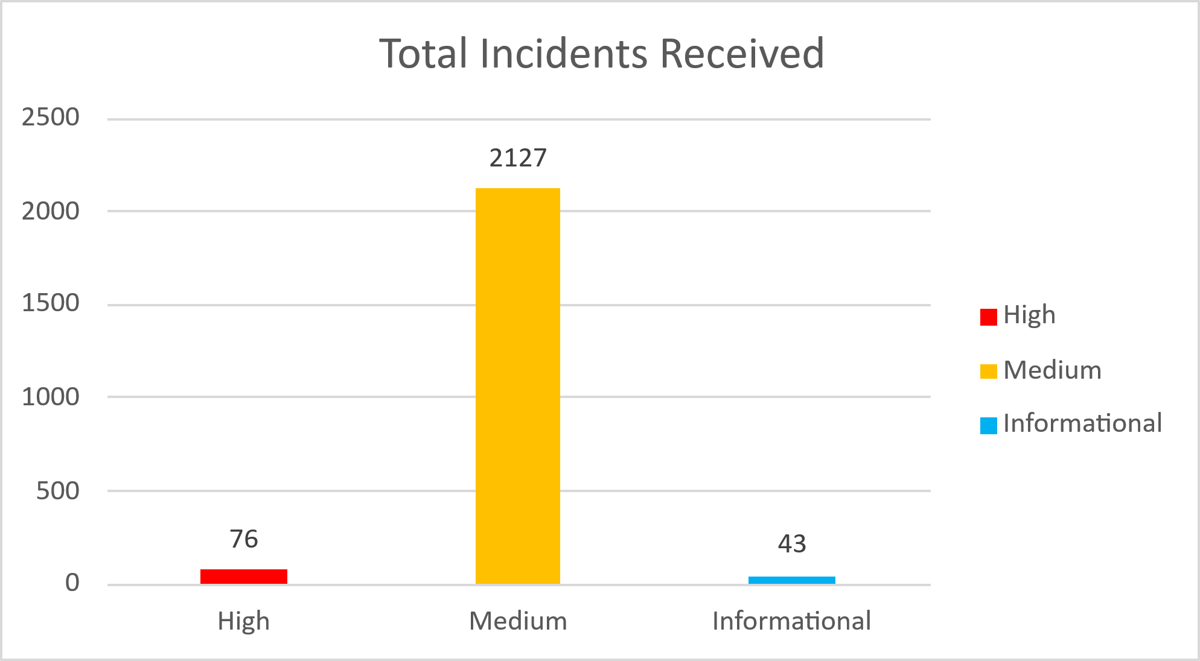

Incidents Processing
During the reporting period, TeKnowledge successfully monitored, detected, and responded to a total of 2246 security incidents within the AB Bank Zambia environment. The SOC team processed all incidents, ensuring a comprehensive approach to threat detection and response.

Mean Time To Detect (MTTD)
The average Mean Time to Detect (MTTD) for this reporting period was recorded at 5 minutes and 11 seconds

Incidents Highlights

Top Incidents by type
During the reporting period, TeKnowledge monitored and categorized security incidents, identifying the most prevalent issues within your environment. Below is a breakdown of the top incident types detected:
Incident Title | Sum of count_
MSSQL Account Logon Failure | 452
FortiGate Successful Login | 328
Admin Account Logon Failure | 309
Brute Force Attempts to Windows Servers | 204
SQL Service Stopped | 175
FortiGate Configuration Change | 98
FortiGate Logon Failure | 76
ABBANK\rm_rasford.lembalemb Has Made Modifications to Group Policy Objects | 75
User Account Modified | 66
Authentication Attempt - Default Account | 52
Grand Total | 1835

Analysis of Key Incident Trends
During this reporting period, TeKnowledge identified and categorized multiple security incidents within the AB Bank Zambia environment. The breakdown below highlights key trends, notable threat patterns, and actionable recommendations to improve detection and response capabilities
- MSSQL Account Logon Failure (452 incidents)
Description: Numerous failed MSSQL login attempts point to attempted from an untrusted domain and cannot be used with Integrated authentication. Thus, aiming at data theft.
Recommendation: Restrict MSSQL access to Applications only, limit access to the minimum required, use strong authentication, enable auditing and monitoring, and implement regular backups.
- FortiGate Successful Login (328 incidents)
Description: A substantial number of successful logins to FortiGate firewalls were observed. While many may be legitimate, the volume requires review to ensure they are not indicative of misuse.
Recommendation: Ensure all logins are properly authenticated using MFA and monitor for login anomalies, especially during non-business hours or from unusual IP addresses.
- Admin Account Logon Failure (309 incidents)
Description: A high number of failed login attempts on administrative accounts were detected, suggesting potential unauthorized access attempts, brute-force attacks, or user misconfiguration.
Recommendation: Implement Just-in-Time (JIT) access controls, enforce Multi-Factor Authentication (MFA) for all admin accounts, and continuously monitor login failures for early detection of potential compromise.
- Brute Force Attempts to Windows Servers (204 incidents)
Description: A brute force attack targeting a Windows Server has been detected. This type of attack involves systematically attempting various username and password combinations to gain unauthorized access. The attacker likely used automated tools to perform repeated login attempts via RDP (Remote Desktop Protocol), SMB, or other authentication mechanisms exposed on the server.
Recommendation: Block the source IP(s) of the attack at the firewall or IDS/IPS. Disable exposed remote services (e.g., RDP, SMB) if not needed. Implement account lockout after 3-5 failed attempts to deter brute force activity. Restrict login attempts to only known, trusted regions. Limit RDP access via VPN or internal network only. Use Network Level Authentication (NLA) for RDP. Review and audit user accounts for unauthorized access. Conduct a vulnerability scan on the server to identify other exposures. Update all patches and ensure endpoint protection is active and up to date.
- SQL Service Stopped (175 incidents)
Description: Multiple SQL service stoppages were recorded, which could indicate maintenance, crashes, or potential security incidents impacting database availability.
Recommendation: Investigate each instance for root cause, validate whether stoppages were planned, and ensure alerting is in place for unauthorized service terminations.
- FortiGate Configuration Change (98 incidents)
Description: Configuration changes were detected on FortiGate devices, which may be related to legitimate administrative actions or unauthorized alterations that could impact network security posture.
Recommendation: Ensure all configuration changes are logged and approved via change management. Review changes for alignment with security policies and enable alerting on unauthorized modifications.
- FortiGate Logon Failure (76 incidents)
Description: Failed login attempts on FortiGate devices may signal unauthorized access attempts to firewall management interfaces.
Recommendation: Harden remote management access, enforce strong password policies and MFA, and restrict access to known IP addresses.
- ABBANK\rm_rasford.lembalemb Has Made Modifications to Group Policy Objects (75 incidents)
Description: A user account (ABBANK\\rm_rasford.lembalemb) has made multiple modifications to Group Policy Objects (GPOs). This could indicate legitimate administrative activity or potentially unauthorized changes that may affect system configurations, user permissions, or security controls across the domain.
Recommendation: Review the changes made to the GPOs and verify if they align with approved administrative tasks. Ensure that GPO modifications are tracked through change management processes, and enable auditing and alerting for unauthorized or suspicious policy changes
- User Account Modified (66 incidents)
Description: Several user accounts in Active Directory were modified.
Recommendation: Review shows that activity was carried out by authorized IT Administrators. Consider adding a second level approval to monitor, approve and audit changes to user account.
- Authentication Attempt - Default Account (52 incidents)
Description: Repeated authentication attempts using default system accounts indicate potential brute-force or credential stuffing attacks by external threat actors attempting to exploit known defaults.
Recommendation: Disable or rename default accounts where possible, enforce strong authentication mechanisms, and monitor for repeated login attempts from suspicious IPs or sources.
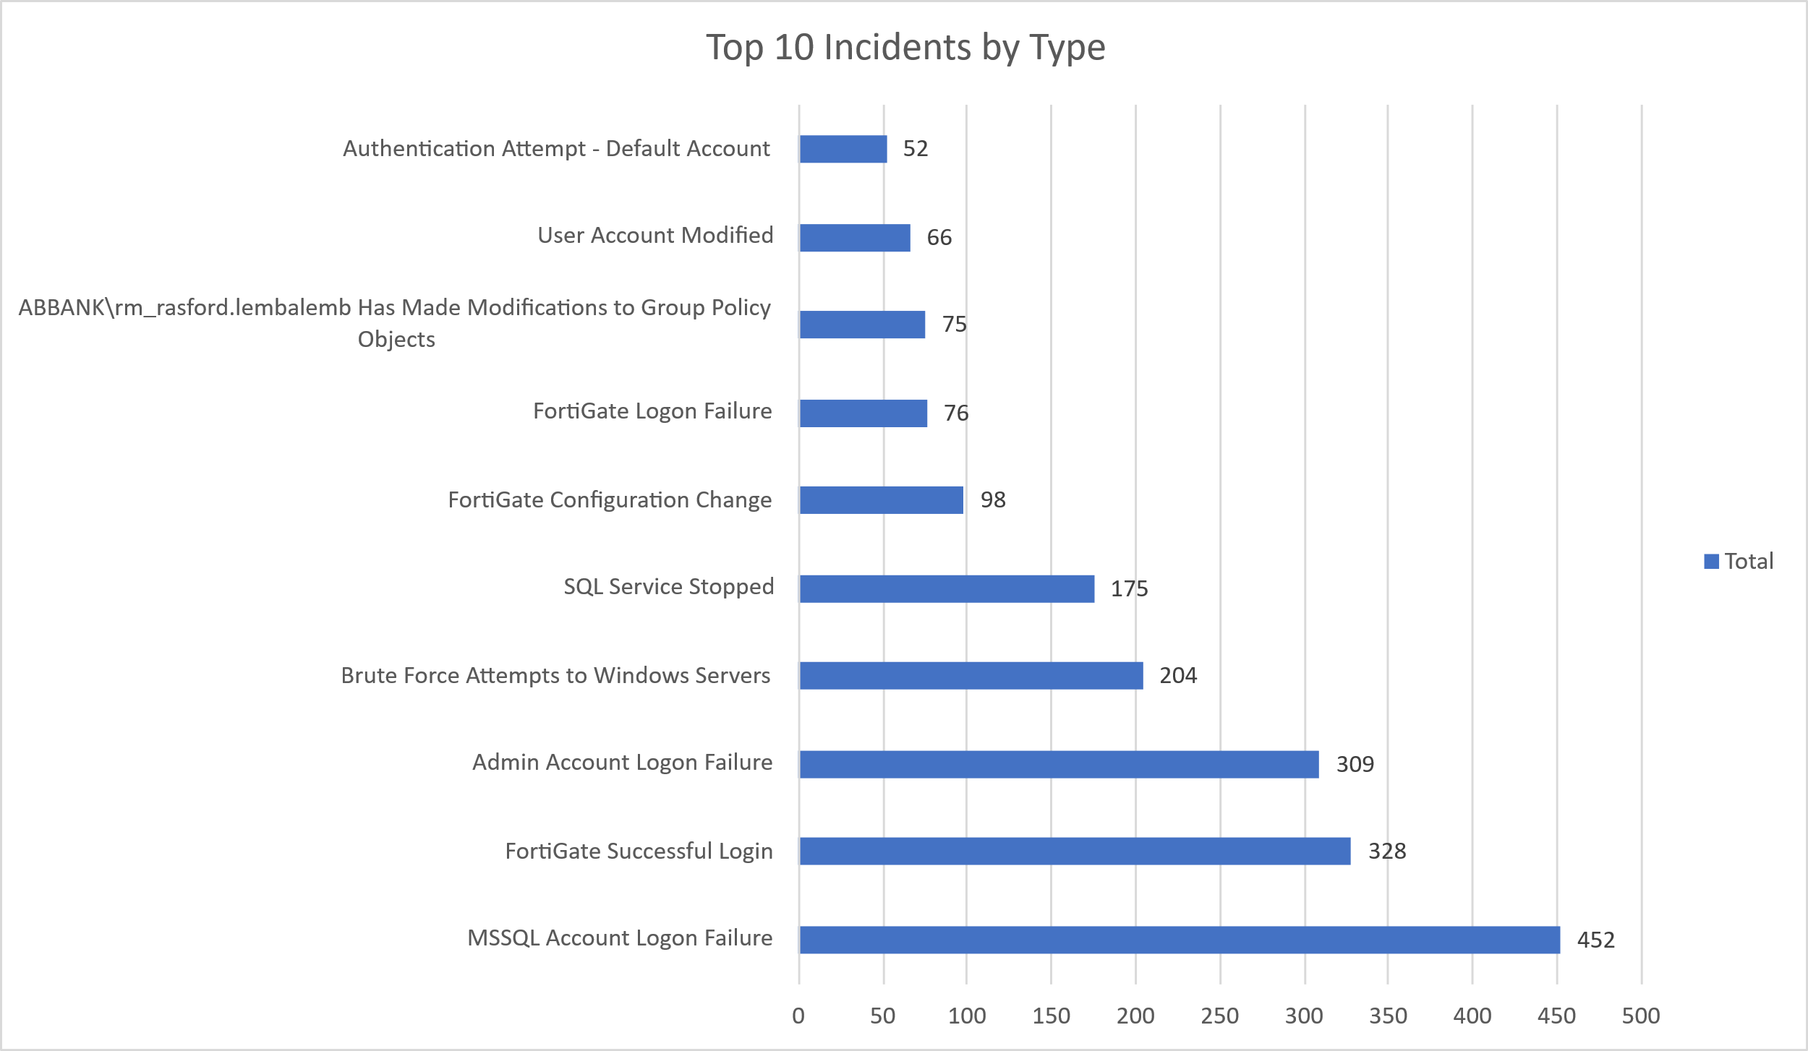

High Severity
During the reporting period, thirty-seven high-severity incidents were recorded. The incidents were thoroughly investigated and determined to be authorized and legitimate.
Incident Title | Sum of count_
ABBANK\rm_rasford.lembalemb Has Made Modifications to Group Policy Objects | 75
ABBANK\rm_mwenya.kaunda Has Made Modifications to Group Policy Objects | 1
Grand Total | 37

High Severity Incidents Analysis
- ABBANK\rm_rasford.lembalemb Has Made Modifications to Group Policy Objects (75 incidents)
Review: All incidents were thoroughly investigated and correlated with known system roles. It was concluded to be Authorized and Legitimate Administrative tasks
- ABBANK\rm_mwenya.kaunda Has Made Modifications to Group Policy Objects (1 incident)
Review: This incident was thoroughly investigated and it was concluded to be Authorized and Legitimate Administrative Activity.

Conclusion and Recommendations

Recommendations
- Enforce Account Lockouts after a threshold of failed attempts (e.g., 3–5 tries).
- Enable Multi-Factor Authentication (MFA) for all administrators and database accounts.
- Monitor login attempts by location/IP — flag geo-anomalies or logins outside business hours.
- Disable unused default accounts, rename admin accounts, and restrict high-privilege logins to known IP ranges or VPN.
- Implement service monitoring and auto-restart policies for critical services like MSSQL.
- Restrict MSSQL access to only internal applications/IPs and over secure channels.
- Apply the principle of least privilege for database users and reduce exposure of login interfaces.
- Review SQL logs and audit settings to trace the root cause of failures

Conclusion
The May 2025 reporting period marked a significant step forward in the security operations of AB Bank Zambia, with TeKnowledge continuing to provide dedicated 24/7 monitoring, incident detection, and rapid response through the Microsoft Sentinel platform. A total of 2,246 alerts were processed—a decrease from the previous month—reflecting the effect of optimized analytical rules in the environment.
The most detected threats included MSSQL Account Logon Failure, Authentication Attempt - Default Account, FortiGate Successful Login, and user account modifications, underscoring the need for sustained vigilance in identity and access management as it relates to critical assets.
TeKnowledge’s SOC demonstrated high operational efficiency, with the following key performance:
- Mean Time to Detect (MTTD): 5 minutes and 11 seconds
- Average Time to First Response: 12 minutes
- Average Mean Time to Resolution: 32 minutes

The high-severity incidents recorded during this period, involving Group Policy Object (GPO) modifications by legitimate administrator (ABBANK\rm_mwenya.kaunda and ABBANK\rm_rasford.lembalemb).

Our incident type analysis revealed that identity-focused threats remain a dominant attack vector, with over 2,000 alerts linked to account authentication failures and access-related anomalies.

